Week 13
Problem Statement:
Given an array of numbers, find the index of the smallest array element (the pivot), for
which the sums of all elements to the left and to the right are equal. The array may not be
reordered.
Example: arr=[1,2,3,4,6]
• the sum of the first three elements, 1+2+3=6. The value of the last element is 6.
• Using zero based indexing, arr[3]=4 is the pivot between the two subarrays.
• The index of the pivot is 3.
Function Description: Complete the function balancedSum in the editor below.
balancedSum has the following parameter(s): int arr[n]: an array of integers
Returns: int: an integer representing the index of the pivot
Constraints
• 3 ≤ n ≤ 105
• 1 ≤ arr[i] ≤ 2 × 104, where 0 ≤ i < n
• It is guaranteed that a solution always exists.
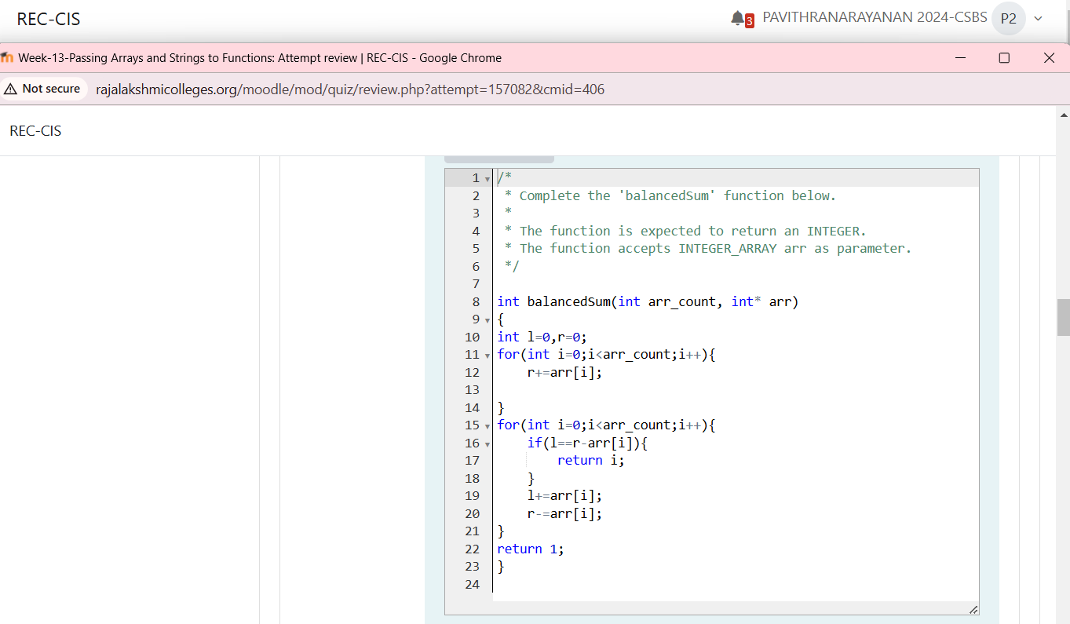
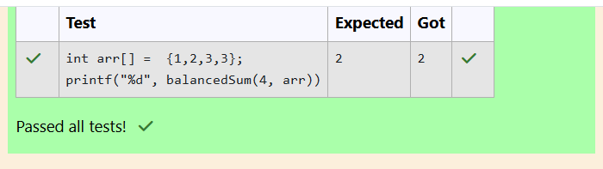
Problem Statement:
Calculate the sum of an array of integers.
Example
numbers = [3, 13, 4, 11, 9]
The sum is 3 + 13 + 4 + 11 + 9 = 40.
Function Description
Complete the function arraySum in the editor below.
arraySum has the following parameter(s):
int numbers[n]: an array of integers
Returns
int: integer sum of the numbers array
Constraints
1 ≤ n ≤ 104
1 ≤ numbers[i] ≤ 104
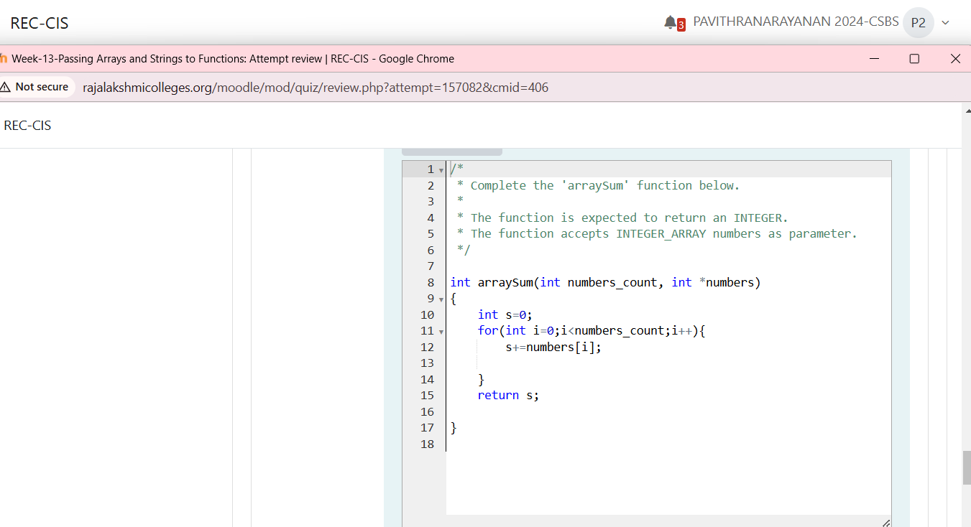
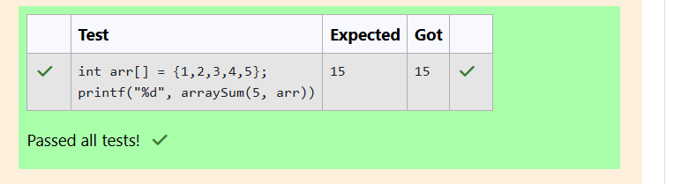
Problem Statement:
Given an array of n integers, rearrange them so that the sum of the absolute differences of
all adjacent elements is minimized. Then, compute the sum of those absolute differences.
Example
n = 5, arr = [1, 3, 3, 2, 4]
If the list is rearranged as arr' = [1, 2, 3, 3, 4], the absolute differences are |1 - 2| = 1, |2 -
3| = 1,|3 - 3| = 0, |3 - 4| = 1. The sum of those differences is 1 + 1 + 0 + 1 = 3.
Function Description
Complete the function minDiff in the editor below.
minDiff has the following parameter:
arr: an integer array
Returns:
int: the sum of the absolute differences of adjacent elements
Constraints
2 ≤ n ≤105
0 ≤ arr[i] ≤ 109, where 0 ≤ i < n
